**Coding challenge**

**Azure Databricks**

**Name: Rohan Vinayak Chaudhari Email:**[**chaudharirohan24@gmail.com**](mailto:chaudharirohan24@gmail.com)

**Batch: Data Engineering 1**

## **Question3**: Execute & explain, Azure datafactory and its copy activity.

**Source Container which contains data:**

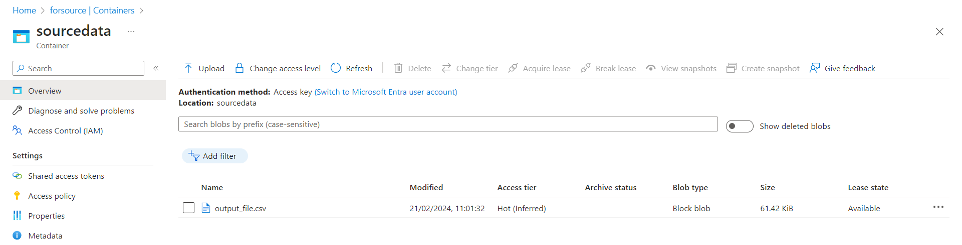

**Destination Container which is empty:**

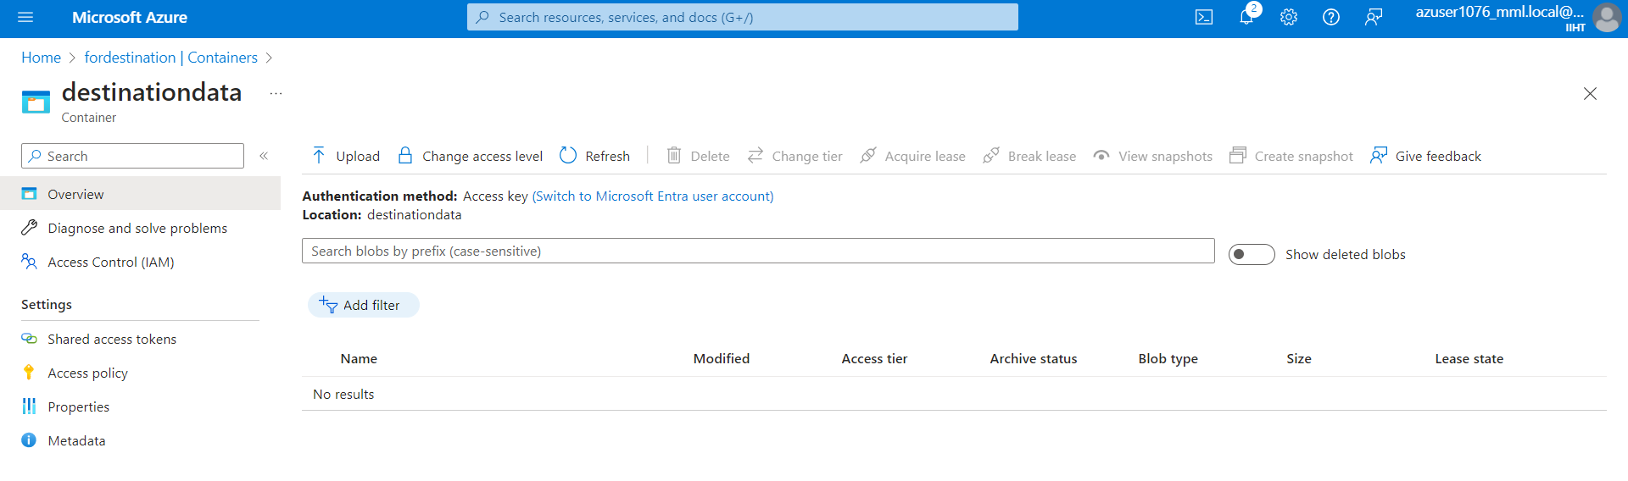

**Created DataFactory:**

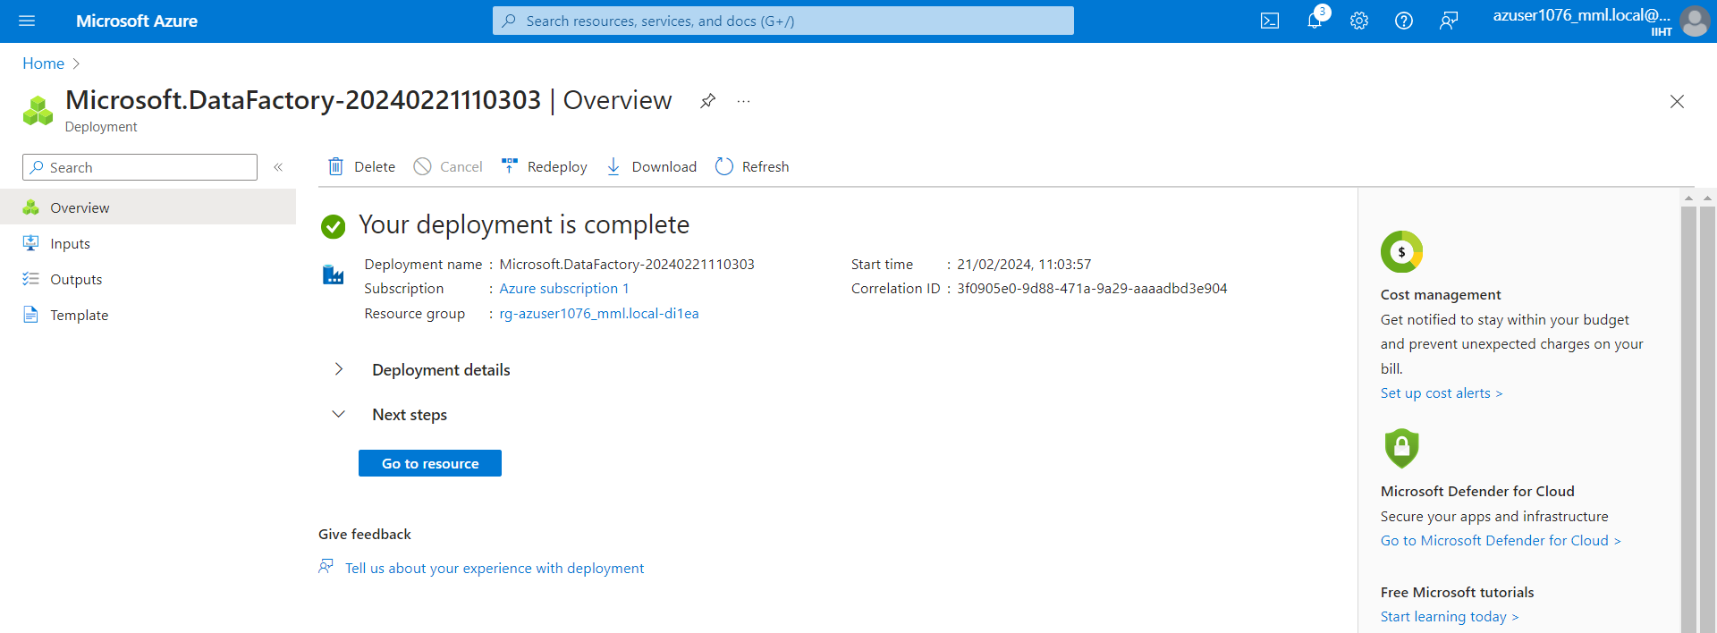

**Created Source Dataset & Tested it successfully:**

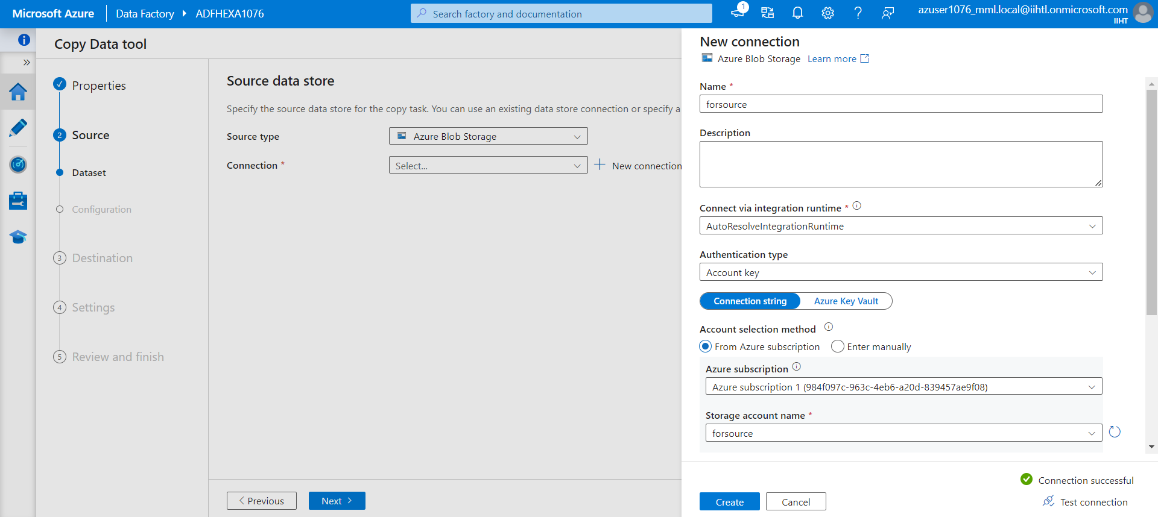

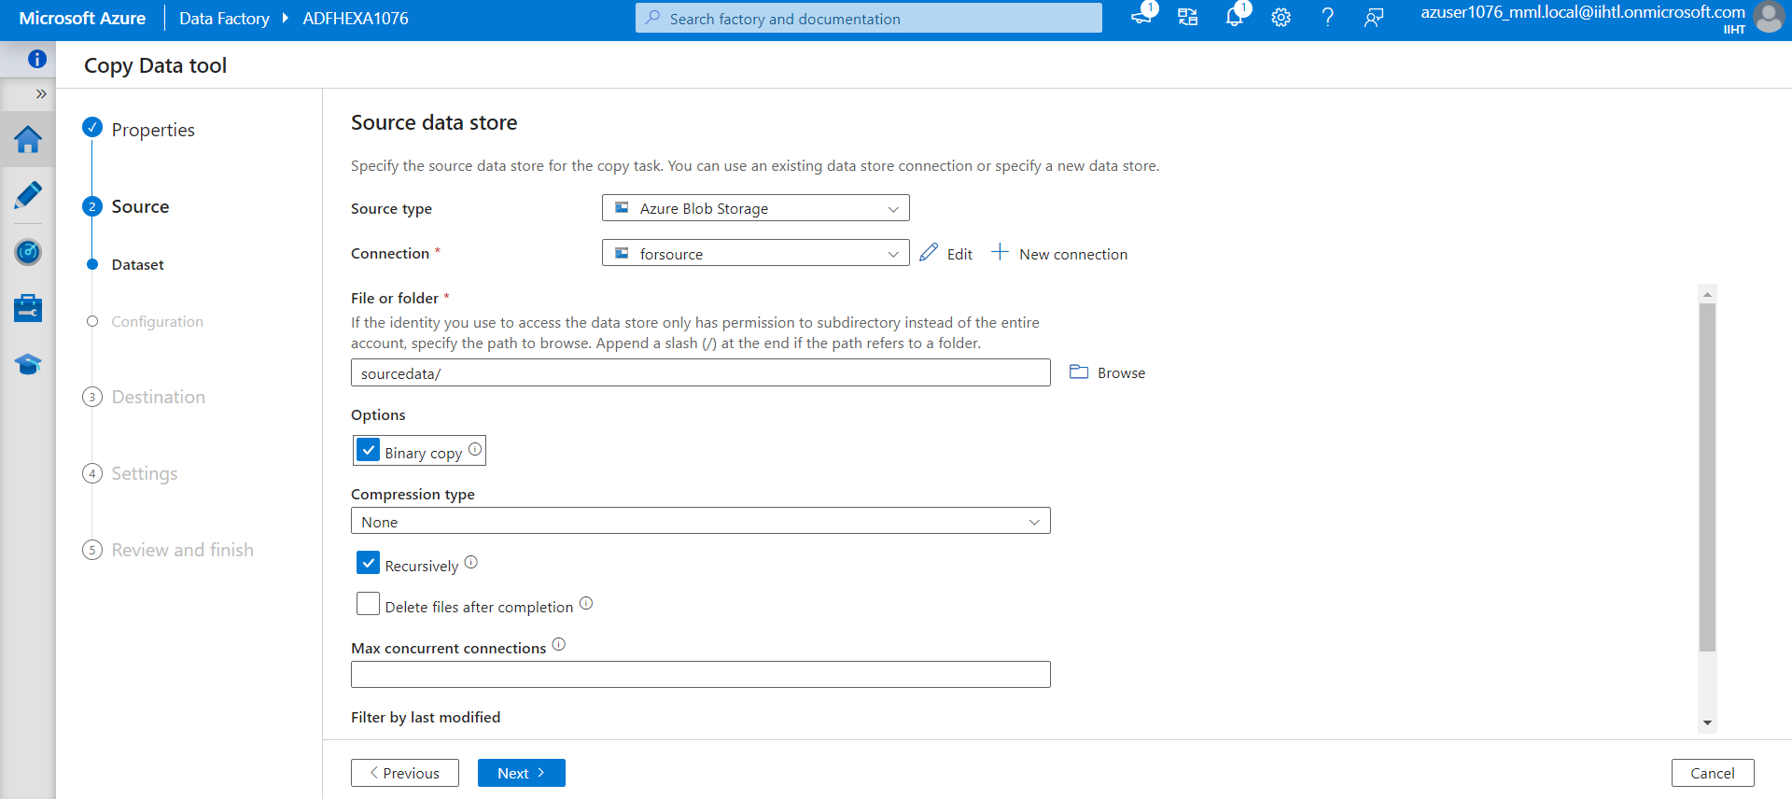

**Created destination Dataset&Tested it:**

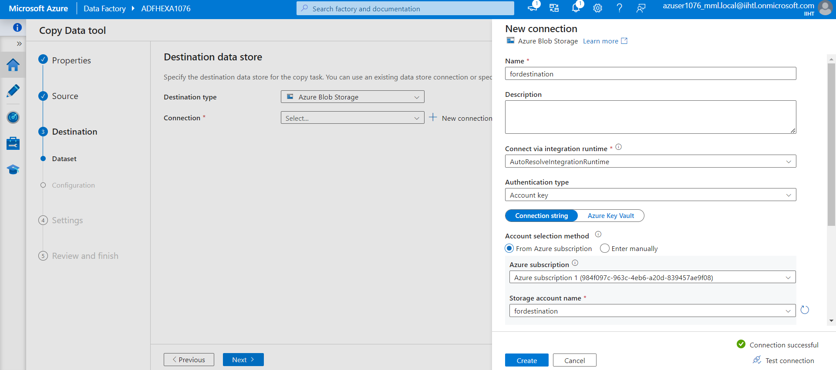

**Assigning Container path:**

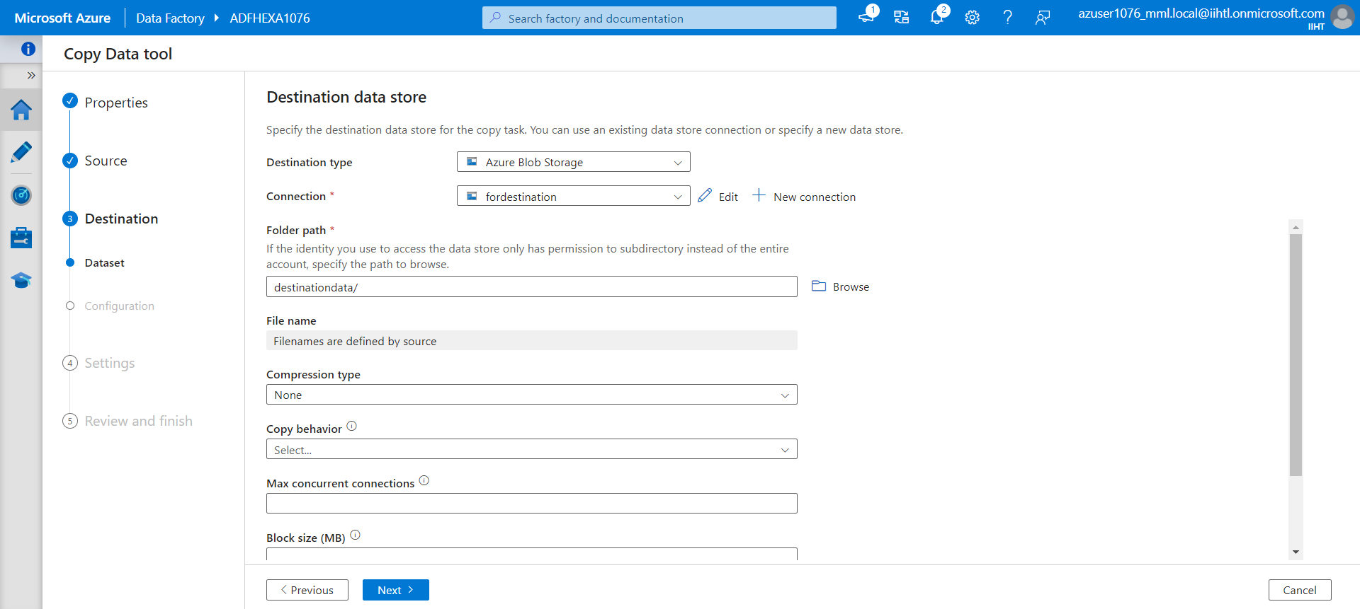

**Created Task:**

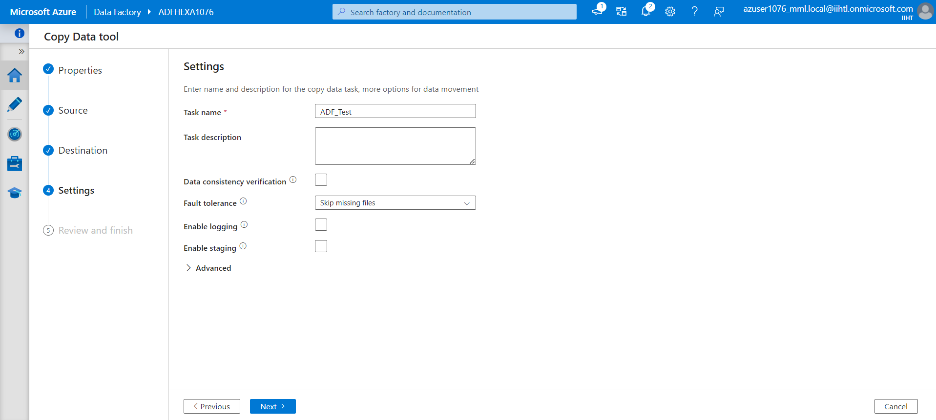

**Reviewing:**

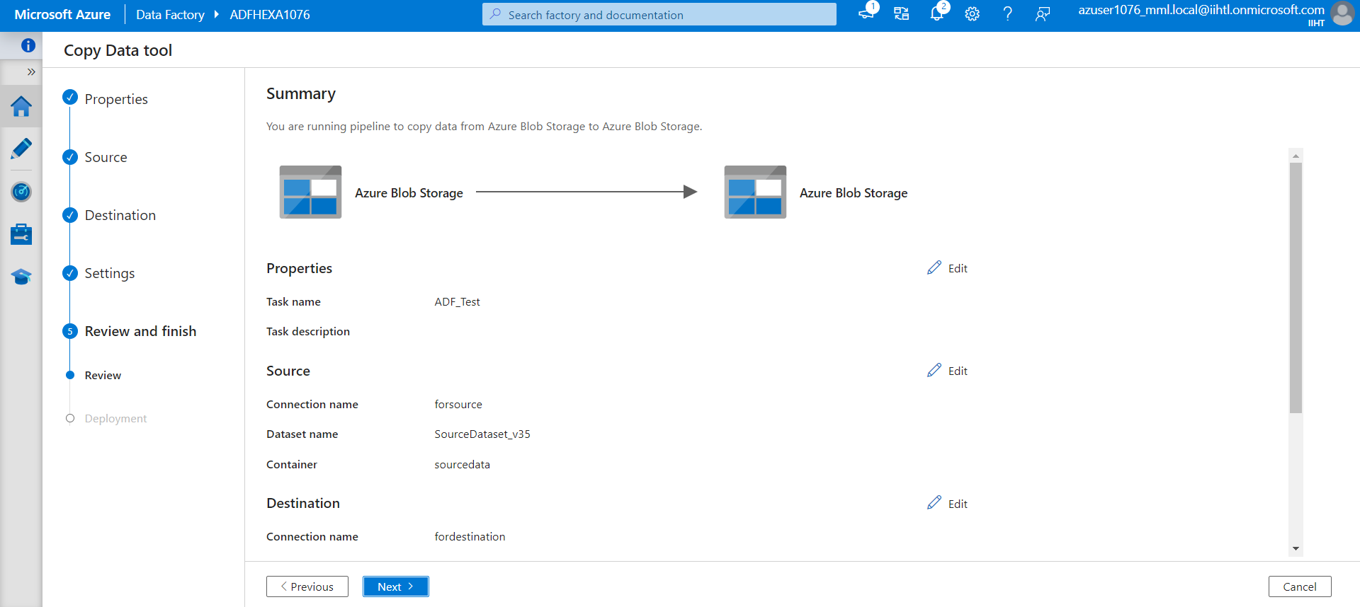

**Deployment:**

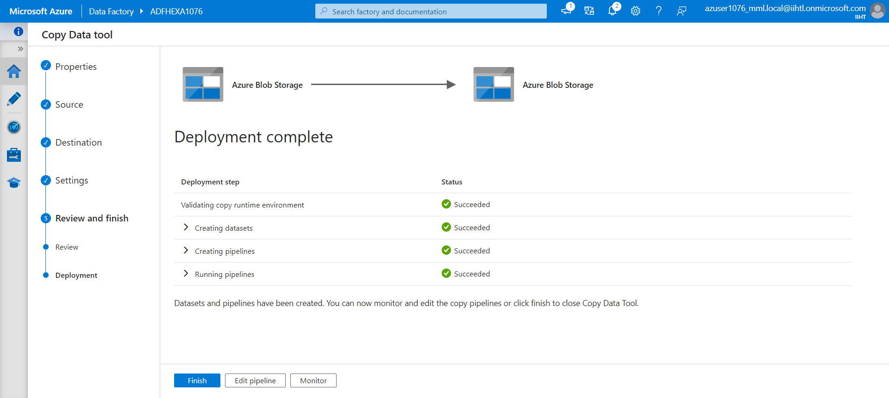

**Here we can see the files are uploaded in destination container:**

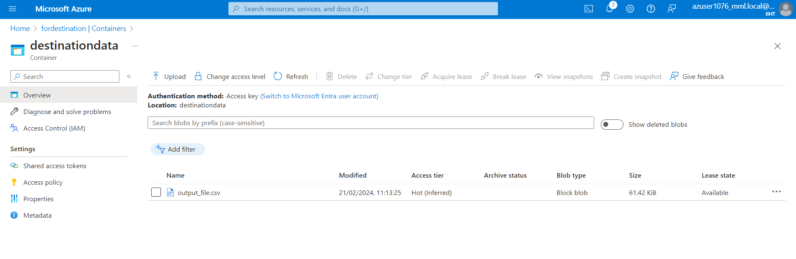

**Now we will try to upload new files:**

**We have debugged the pipeline for copying new file and it is successfully copied:**

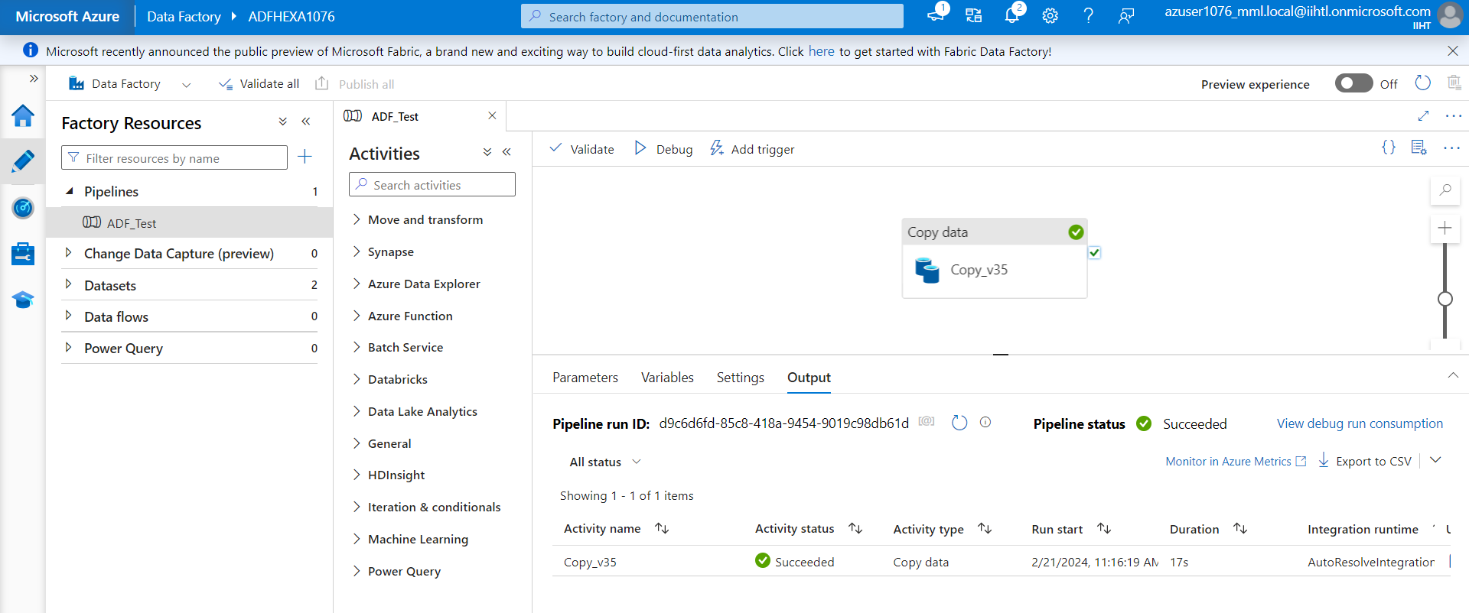

**In our destination folder New file has be copied:**

